Prototype, Performance and Methodologies

PROG3A

Nicole Willemse

  St10114295

Table of Contents

INTRODUCTION 1

OPTIMIZATION OF PROTOTYPES PERFORMANCE 1

Ways to optimise our prototype performance. 1

Considerations for the final product 1

Software Development Methodology 2

Benefits 2

Implementing DevOps 3

DevOps Benefits 3

Recommended Enterprise. 4

References 5

# INTRODUCTION

Without a website, Farm Central, cannot track their incoming and outgoing stock and there will be no way to keep track of which items belongs to which farmer.

Therefore, our team would love to create a website for you that can assist your employees and farmers keep track of the stock.

In this proposal, I have outlined ways in which the performance of the prototype can be optimised, the recommended software development methodology that will be implemented for this development effort. I have highlighted some key points when it comes to the topic of DevOps and which enterprise architecture, I think is best for this project.

# OPTIMIZATION OF PROTOTYPES PERFORMANCE

When thinking about application performance optimisation, the two kinds of metrics to consider are the duration of code execution and the number of resources it uses while doing so (IIE The Independent Institute of Education, 2023). Optimising application performance, requires analysing the problem, identifying the bottlenecks, and then fixing them.

## Ways to optimise our prototype performance.

* **Avoid premature optimizations.**

The C# code will be written to be clean and straightforward, making it easier to read.

* **Limit the number of concurrent operations.**

By using the ‘SemaphoreSlim,’ the number of concurrent operations is control, without risking readability and maintainability issues.

## Considerations for the final product

1. No time will be wasted on perfecting small details like materials and colour, instead we will focus on building an object that matches the vision of ‘Farm Central’.
2. We will be more agile, by taking regular feedback, after presenting the weekly progress, and make changes where necessary.
3. We will minimise testing variables, by using simpler scenarios at first and figure out what the root cause of the issue is. After finding the problem from those straightforward evaluations, we will move on to the complex situations.

# Software Development Methodology

The Recommended Software Development Methodology is Kanban.

Kanban is an agile methodology, which has been in use since 1940 and plays a significant role in many production units (IIE The Independent Institute of Education, 2023; Wakode, et al., 2015). Kanban optimizes workflow, with the Kanban practices (Bhavsar, et al., 2020).

Kanban is flexible and we will be working on one thing at a time, so we will be able to make changes easily and tend to the customers needs. It will ensure that the data is accurate, eliminate any bugs, ensure for the ease of us.

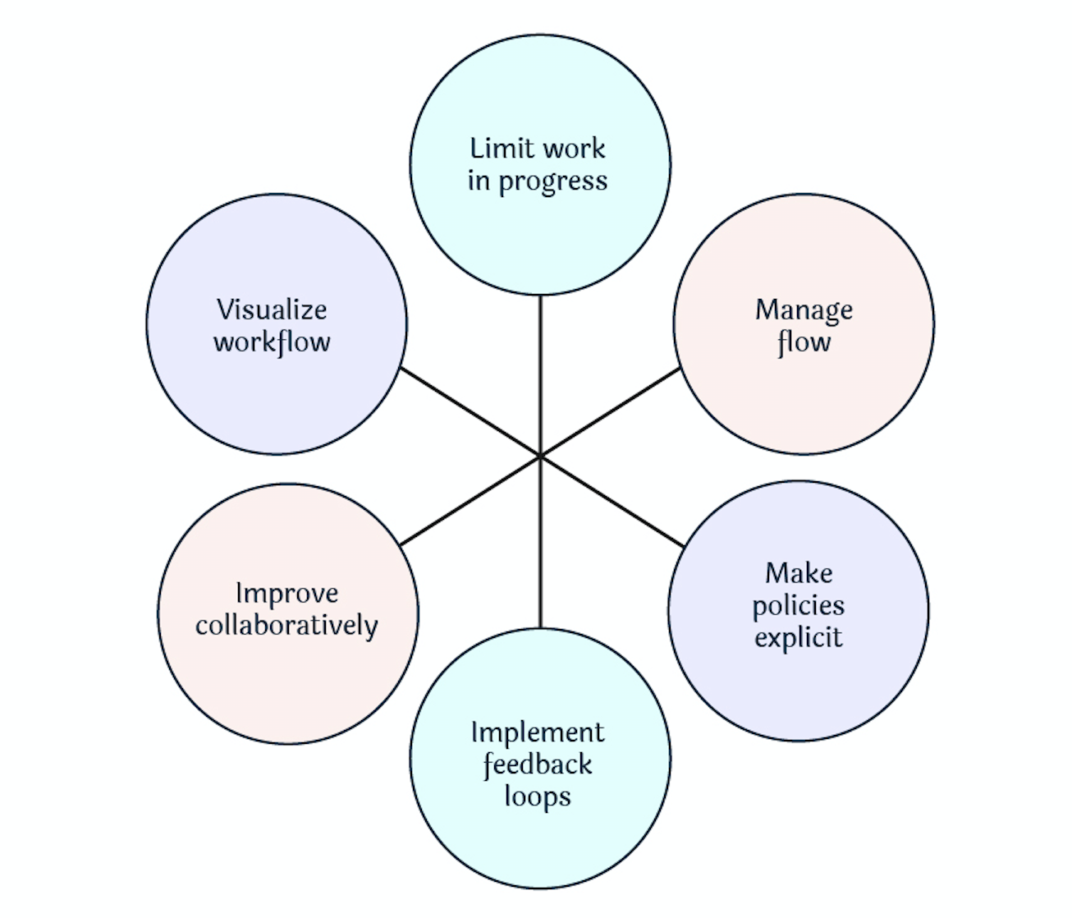

Figure shows the essential Kanban practices.

## Benefits

* Project managers are able to assess the project performance and make accurate estimations, which minimises risks.
* Kanban helps in managing production of a product.
* It increases communication between the team and stake holders.
* There is a positive impact on external quality of the system.
* Kanban in flexible; the team would be able to adapt to customer needs.
* It is a simple methodology and can be grasped easily,
* Software can be delivered regularly, ensuring a timely delivery.

# Implementing DevOps

I would recommend implementing DevOps, because it aims to bring teams together, traditionally development and operations, and breakdown the obstacles that a silo mentality and tight compartmentalization impose. Silos are eliminated by creating a combined process that focuses on visibility-powered collaboration. Kanban is a DevOps method, used to speed and improve development and product releases.

## DevOps Benefits

DevOps is a shared culture of responsibility, which brings transparency and faster feedback is built.

It helps with faster product delivery.

It offers greater scalability and availability.

Provides faster issue resolution and reduced complexity.

Figure shows stages of DevOps pipeline.

# Recommended Enterprise.

I would recommend using a combination of Information Technology Infrastructure Library (ITIL) and The Open Group Architecture Framework (TOGAF).

The purpose of the prototype stock management website, is to track incoming and outgoing stock and to which farmer each item belongs to. ITIL is considered to be a good and common practice that is able to manage IT Services Management (ITSM) (Khwarizma, et al., 2017). According to (Dabade, 2010), ITIL is the most widely accepted approach to IT Services Management in the world. ITSM is a subset of Service Science, focusing on IT operations, like service delivery and support, and how IT teams manage to deliver to the customer (Galup, et al., 2009). ITIL will ensure the software’s stability, availably, performance, as well as the overall customer satisfaction.

Figure shows the ITIL Process Categories

TOGAF is an industry standard architecture framework that can be freely used by any enterprise developing enterprise architecture for use within [17] (Saha, n.d.). This enterprise architecture framework provides a holistic approach and well-aligned solution architecture, which ensures for the software’s seamless integration and the long-term business support (Andry, et al., 2023). ```` 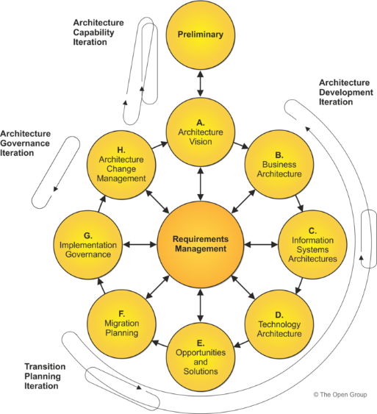

Figure shows TOGAF ADM Cycle

# References

Andry, J. F., Sugian, D., Kartin, M. & Pranamya, D., 2023. Enterprise Architecture Design Using The Open Group Architecture Framework (TOGAF) at Logistic Courier Services. *IT Journal Research & Development,* 7(2).

Dabade, P. T. D., 2010. *INFORMATION TECHNOLOGY INFRASTRUCTURE LIBRARY (ITIL).* [Online]   
Available at: http://bvicam.in/INDIACom/news/INDIACom%202010%20Proceedings/papers/Group3/INDIACom10_11_Paper%20(4).pdf  
[Accessed 20 June 2023].

Galup, S. D., Dattero, R., Quan, J. J. & Conger, S., 2009. An overview of IT service management. *Communications of the ACM,* 52(5), pp. 124-127.

Khwarizma, A. F. et al., 2017. *A study of Information Technology Infrastructure Library (ITIL) framework implementation at the various business field in Indonesia.* [Online]   
Available at: https://ieeexplore.ieee.org/abstract/document/8089244/authors  
[Accessed 21 June 2023].

Saha, P., n.d. *Analyzing The Open Group Architecture Framework from the GERAM Perspective.* [Online]   
Available at: https://www.opengroup.org/architecture/wp/saha/TOGAF_GERAM_Mapping.pdf  
[Accessed 22 June 2023].